jPG

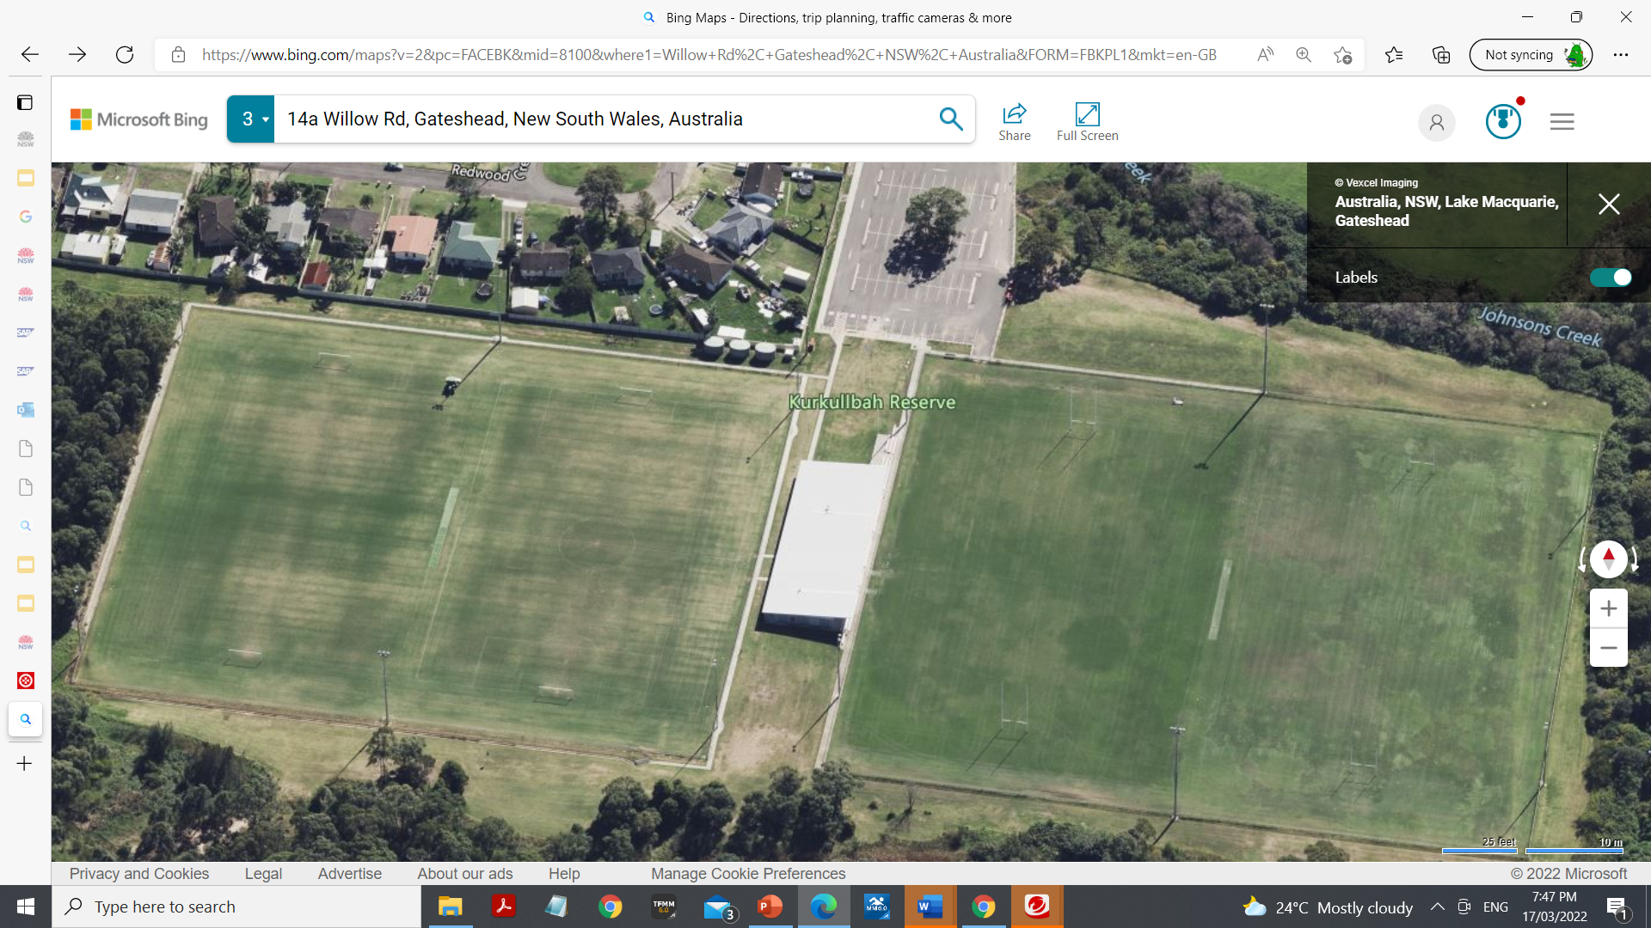

Gate

Gate

Recording Area

Finish

**John C** **CS**

**James B H**

**Stiven M** **CE**

**Jenna E**

**E**

**Lisa B** **WB**

**Ben CB**

**Kat BN**

**START**

**Mal R Will B**

**MP**

**Raquel/Mark MP**

**MP**

**Daisy J**

**MP**

Union Field roped off.

**Brian G** **C**, **Craig E** **P Anthony V**

Juniors 8/9, 10, Multiclass Students

Start……on top left corner of soccer field……across to Stiven……..down past Kat………to gate with John………over to Gate Lisa Bath……..along the botton of union fields past Daisy to the corner to James…….running up to Ben…..across to Raquel……down past Brian, Craig, Anthony to Daisy and back to Lisa….. out the gate across to the other……past John…..across to Jenna……back to the start (one full lap) ……. Do this again BUT after doing the lap of the union fields, go out through the gates…..go past John and across to Jenna……go up to Kobe who will direct down to the finish line.

Seniors 11, 12/13

Do the same track as the Juniors but they do 2 full laps and on the third lap after coming through the gates onto the soccer fields they go past John to Jenna……Kobe to direct to the finish line.

**Kobe S**

School Area behind Fence

**Raquel /Mark MP**

**Jewells PS**

