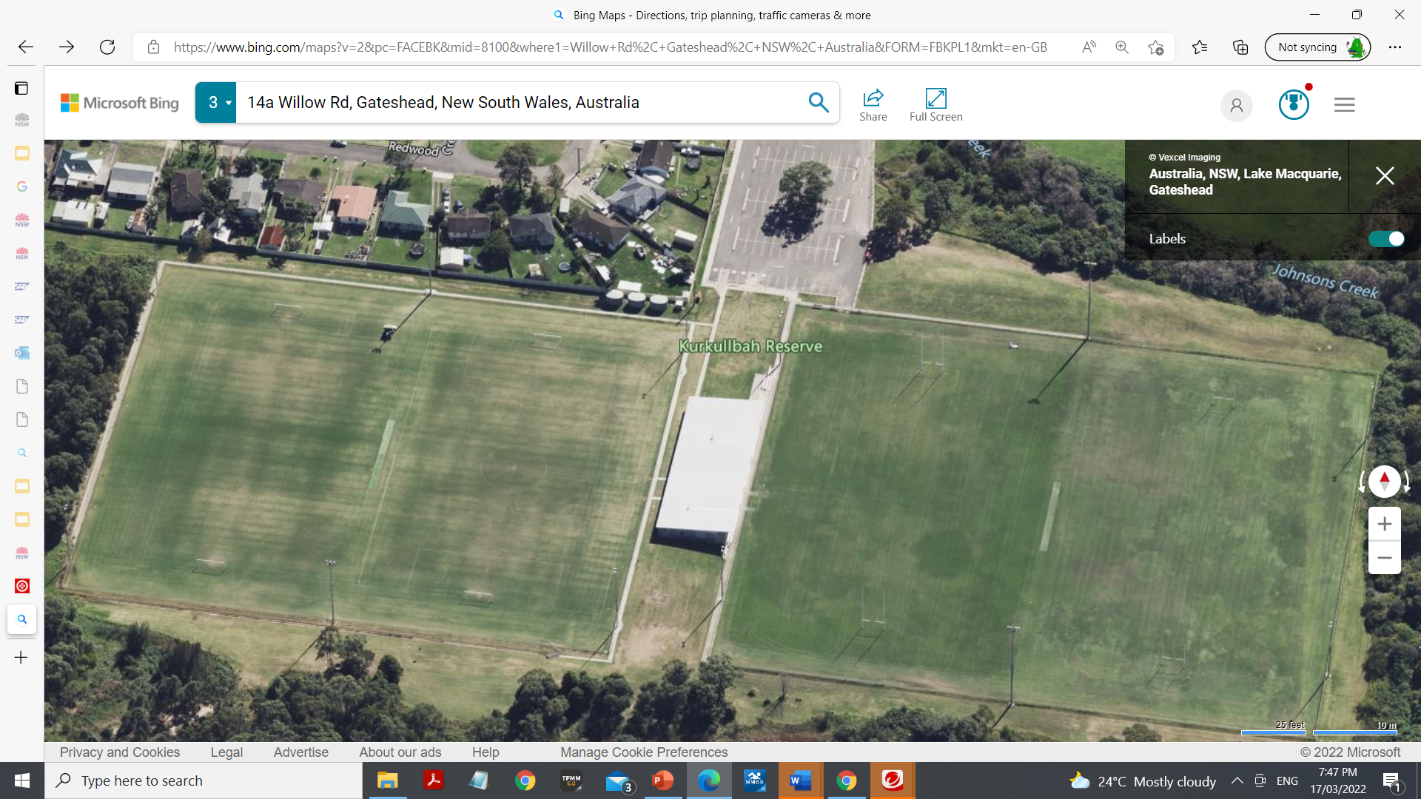
jPG
Gate
Gate
Recording Area
Judy/Evan K
Places
1-5 Mark B
6-10 Damian WIR
11-15 Lilli WIN
16-20 Mark/Raquel MP
21-25 Lachlan MH
Swansea to bring place getters across in order.

Finish
Brian G C

James B H
Stiven/ Daniel CE
Lee V
E
Lisa B WB
Hayden CB
Rhys BN
START
Mal R Ryan F

MP
Dudley

MP
Daisy J

MP
Jack E

John CS
Mitch B
School Area behind Fence

Raquel /Mark MP
Jewells PS

