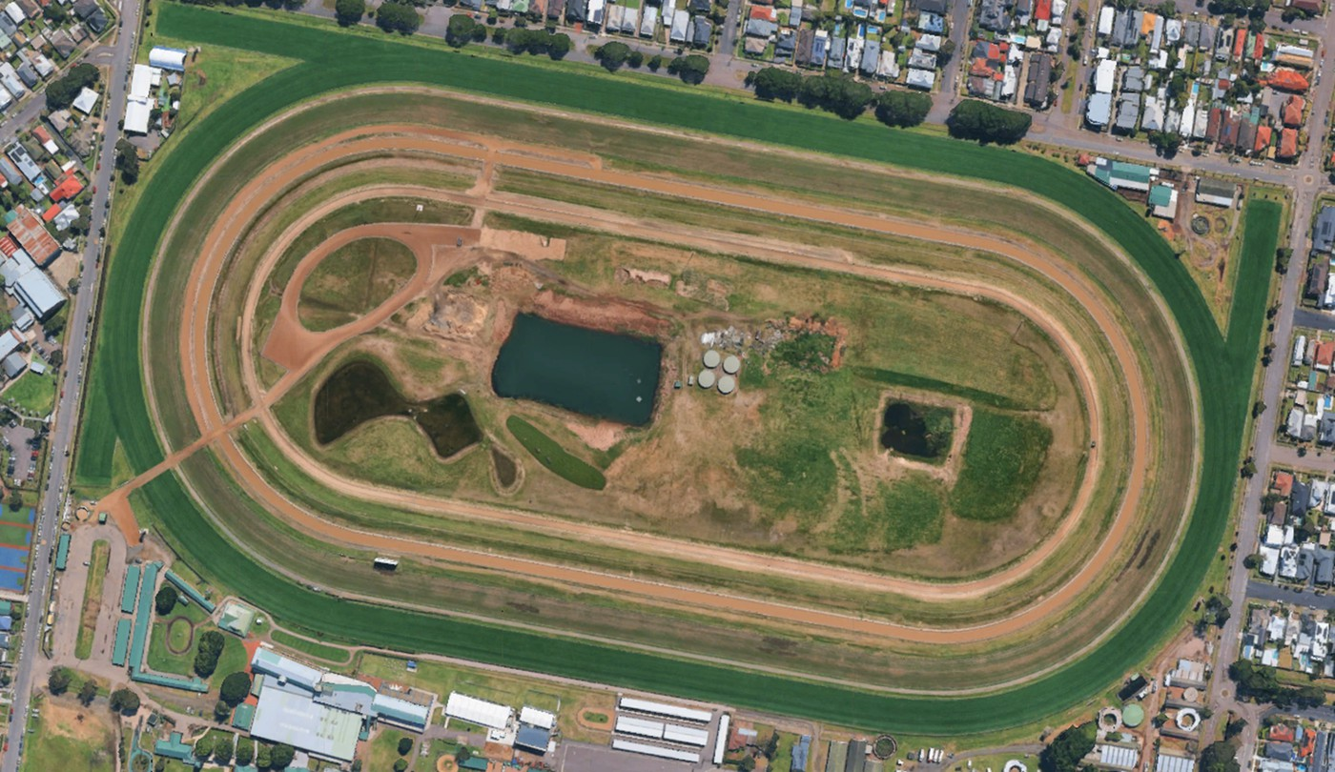




2km Track
E
D
C
F
Start
A
Marshalling
Recording tent
Apparel
B
Finish






E
D
G
H
3km Track
C
F
Start
A
Marshalling
Finish
Recording tent
Apparel
B

